Permanent Address:
Limiya Mol Thankachan
Kottakakathu House
Mammattikanam P.O
Pazhayaviduthy
Idukki District
Pin– 685566
Kerala- India
E-Mail : Limiyathankachan22@Gmail.Com
Mob : +919656251022

Currently resides in Rajakad , Kerala
RESUME 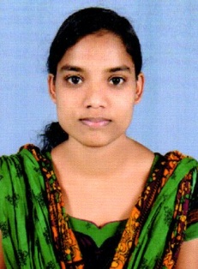

Career Objective

To work in a firm with a professional work driven environment where I can utilize and apply my knowledge and skills which would enable me as a fresh graduate to grow while fulfilling organizational goals.

KEY SKILLS

- Good team player
- Willing to work and adapt new challenges
- Self motivation and a passion to succeed
- Happy to relocate and experience new things

AREA OF INTEREST

Programming languages:
C and C++
Java
HTML
Visual Basics
PHP
academic Qualification

EXAM / DEGREE | YEAR | NAME OF INSTITUTE | UNIVERSITY / BOARD | PERCENTAGE
BSc. CS | 2016 | College of Applied Science Nedumkandam | Mahatma Gandhi University | 73%
XII | 2013 | Govt.HSS Rajakad | State | 74%
X | 2011 | Govt.HSS Rajakad | State | 64%

PROJECT PROFILE
1. Project title | Main project
Project topic | Claim Management System
Description | The Claim management system project in ASP.NET is being developed to provide a tool for the different organization to easily maintain the Claim process.

PERSONAL DETAILS

Date of Birth : 22th may 1995
Gender : Female
Languages known : English, Malayalam
Nationality : Indian
Marital Status : Single

Declaration:
I hereby declare that the information furnished above is true to the best of my knowledge.

Yours Sincerely
Place: Rajakad - Kerala 
Date: LIMIYA MOL THANKACHAN

